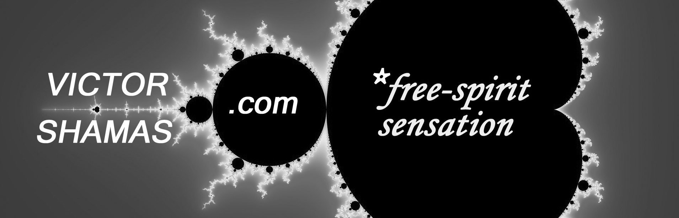
FIVE QUESTIONS FOR DR. VICTOR SHAMAS ABOUT
DEEP CREATIVITY: INSIDE THE CREATIVE MYSTERY

What is Deep Creativity?
Deep Creativity is an entirely new way of understanding creativity based on a lifetime of research. As a University of Arizona psychologist, I devoted 30 years of my life to examining the writings and verbal reports of painters, writers, dancers, composers, poets, sculptors, and inventers. For much of that time, I also immersed myself in the creative process, keeping thorough notes as I created music, books, videos, and inventions. When I compared my own experiences to those of eminent artists, I uncovered a set of patterns that form the foundation of a new field, which I call “Deep Creativity.” This field is based on Ten Tenets that reveal surprising truths about the nature of creativity.
Why did you feel a need to study creativity in this unorthodox way?
I entered the field of psychology to understand the relationship of consciousness and creativity. As a psychologist, I have always been fascinated by the kinds of peak experiences that result in creative breakthroughs. I want to know what these experiences feel like and why they often lead to the creation of fresh ideas and insights. Very early in my career, I found that psychology did not have a particularly good grasp of the creative experience. Part of the problem has to do with the methods used by most creativity researchers. If you are on the outside looking in on the creative experience of others, you may never get an accurate sense of what it feels like to create. I decided that it was not enough to be an observer; I had to participate in the creative process myself. So, I began to immerse myself in my own creative experience on a daily basis. Only then was I able to begin penetrating some of the profound mysteries of creativity.
And what did you discover in your personal exploration of the creative process?
The more I delved into the creative process, the more I discovered that many common assumptions about the nature of creativity were false or misleading. For instance, we tend to equate creativity with thinking and problem-solving, when in actuality it has far more to do with feeling and sensation. Albert Einstein wrote, “The intellect has little to do on the road to discovery.” I found that the intellect can actually get in the way of the creative experience. Nothing puts a damper on creativity like judgment, analysis, or expectation. I came to the conclusion that creativity is not just thinking outside the box but living outside it.
What does it mean to “live outside the box”?
None of us is going to become more creative by just thinking outside the box. Our thinking is what made the box in the first place! Every thought limits our creativity by restricting what we know to be true about ourselves and our world. Creativity often emerges from a pure and profound experience that is free of all thoughts. In this mental silence, we come in contact with the true source of our creativity. To gain access to this source, we do not need to think harder or be smarter. Creativity has much more to do with passion, intuition, and imagination than with intelligence. You do not need to be a genius in order to create, but you do need to be open to a bold adventure. Entering into this adventure takes an element of courage because it will pull you away from ways of thinking that are considered safe or acceptable. This is what it means to “live outside the box.” Your life becomes a creative adventure in pursuit of an experience that is fresh and transcendent. This creative experience can lead to intense joy and fulfillment, but it does not necessarily conform to social norms or conventions.
How does Deep Creativity change our understanding of creativity?
Because we live in a results-oriented society, we tend to focus on products over process. This bias is common among the scientists who study creativity. They assess and evaluate the quality of creative products, such as writing samples, drawings, or inventions, without offering much insight into the process that gives rise to these products. When they do try to examine the process, they focus on thinking rather than experience. That is why our current understanding of creativity is so limited. Ironically, we are trying to squeeze a few droplets of creativity out of a source that is as vast and powerful as any ocean. Under the right conditions, we could be diving into that ocean of creativity and harvesting a wealth of insights and breakthroughs for the benefit our world. We live in a time when virtually every aspect of our lives has to be reinvented or re-imagined in order to assure the future of human civilization. The need for the understanding that Deep Creativity can provide has never been greater.
Yet, the emphasis of Deep Creativity has nothing to do with solving problems or getting results. All of my work, including Deep Creativity, focuses on a type of peak experience in which we feel fully alive and so completely immersed in the moment that time stands still, all distractions disappear, and we literally lose ourselves. This experience happens to be the vehicle through which we gain access to the source of our creativity, but that is not what makes it so compelling—at least not to me. I am drawn to an experience that connects me to the most profound truths of human existence and the fundamental core of our identity as human beings. In my exploration of Deep Creativity, I have seen overwhelming evidence of an undeniable truth: that we are greater than we ever imagined. My intention, in writing Deep Creativity: Inside the Creative Mystery, is to reveal and celebrate the virtually limitless nature of the human spirit.

