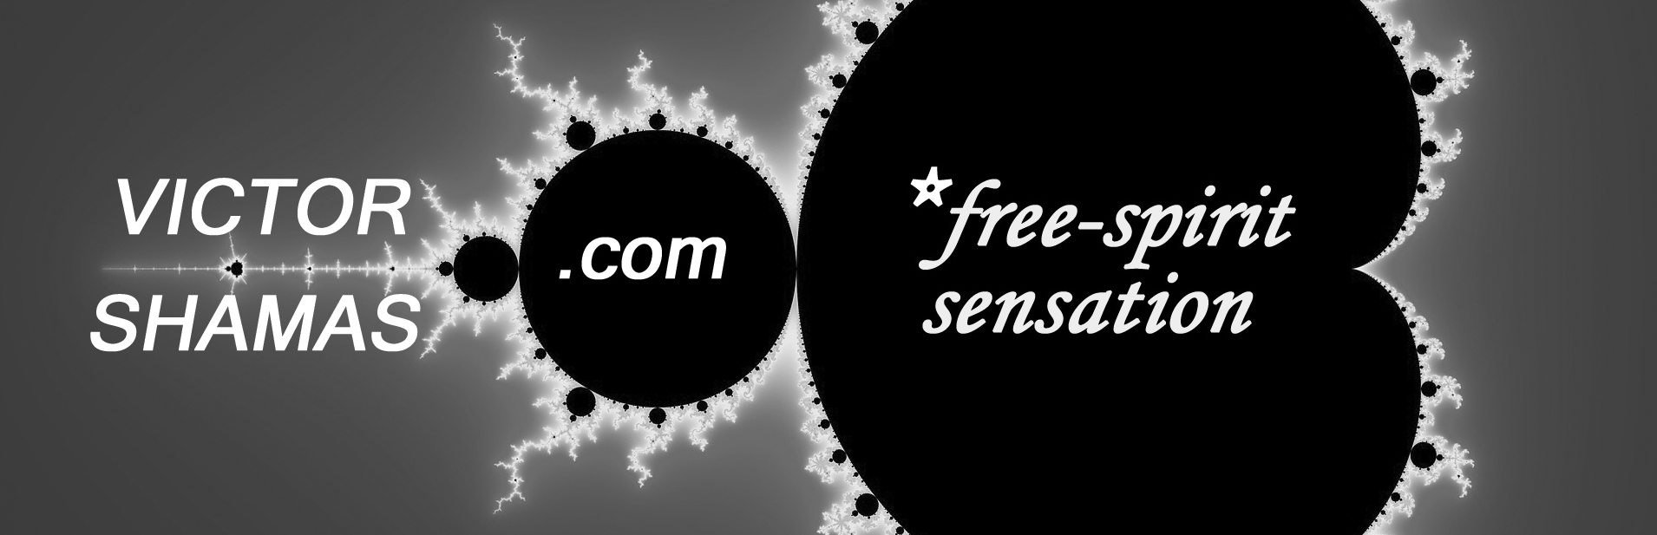

N E W S R E L E A S E: For Immediate Release

Feelings and Sensations, Not Thoughts, Give Rise to Creativity

Most of us are looking for creativity in all the wrong places. So claims Dr. Victor Shamas, who as a University of Arizona psychologist devoted 30 years of his life to the exploration of creativity. In his newly-published book, Deep Creativity: Inside the Creative Mystery, Shamas challenges fundamental assumptions about creativity.

According to Shamas, “Creativity is not just thinking outside the box but living outside it.” He observes that artists throughout history have been inspired by a type of profound creative experience which has little to do with thinking or intellect. “In reality, thinking can get in the way of the creative experience,” Shamas claims. “Nothing puts a damper on your creativity like judgment, analysis, or expectation.”

To understand the nature of creativity, Shamas decided to abandon conventional scientific methods and immerse himself in the creative experience first-hand. For two decades, he kept thorough notes as he created music, books, videos, and inventions. When comparing his experiences to those of other creative individuals, he uncovered a set of patterns that form the foundation of a new field of study, called Deep Creativity.

“In Deep Creativity, the experience is everything.” Shamas explains, “The more deeply you delve into the creative experience, the more you uncover the secrets not just of creativity but of human existence.” By focusing on feelings and sensations as opposed to thought processes, Deep Creativity reveals important insights into the true source of creativity, the cyclical nature of the creative process, and the wealth of creative ideas accessible to virtually anyone under the right circumstances.

One of the reasons Shamas wrote Deep Creativity was to dispel the misconception that creativity is the birthright of only a few elite geniuses who can outthink everyone else. “Creativity has never been about thinking harder or being smarter,” notes Shamas. “It has much more to do with passion, devotion, joy, self-transcendence, and unconditional love. These are qualities that any of us can develop.”

Shamas maintains that Deep Creativity serves an urgent societal need. “We live in an age when the future of human civilization is very much in doubt. No other era has demanded as much creativity as the present,” he observes. “As a species, we are in the unique position of having to re-imagine and reinvent virtually every aspect of our lives. That is why the understanding that Deep Creativity can provide is so important now—perhaps more than at any other time in human history.”

For more information or to schedule an interview with Dr. Shamas, please call 520-838-4194 or email victor@victorshamas.com.

