Deep Creativity
Inside the Creative Mystery

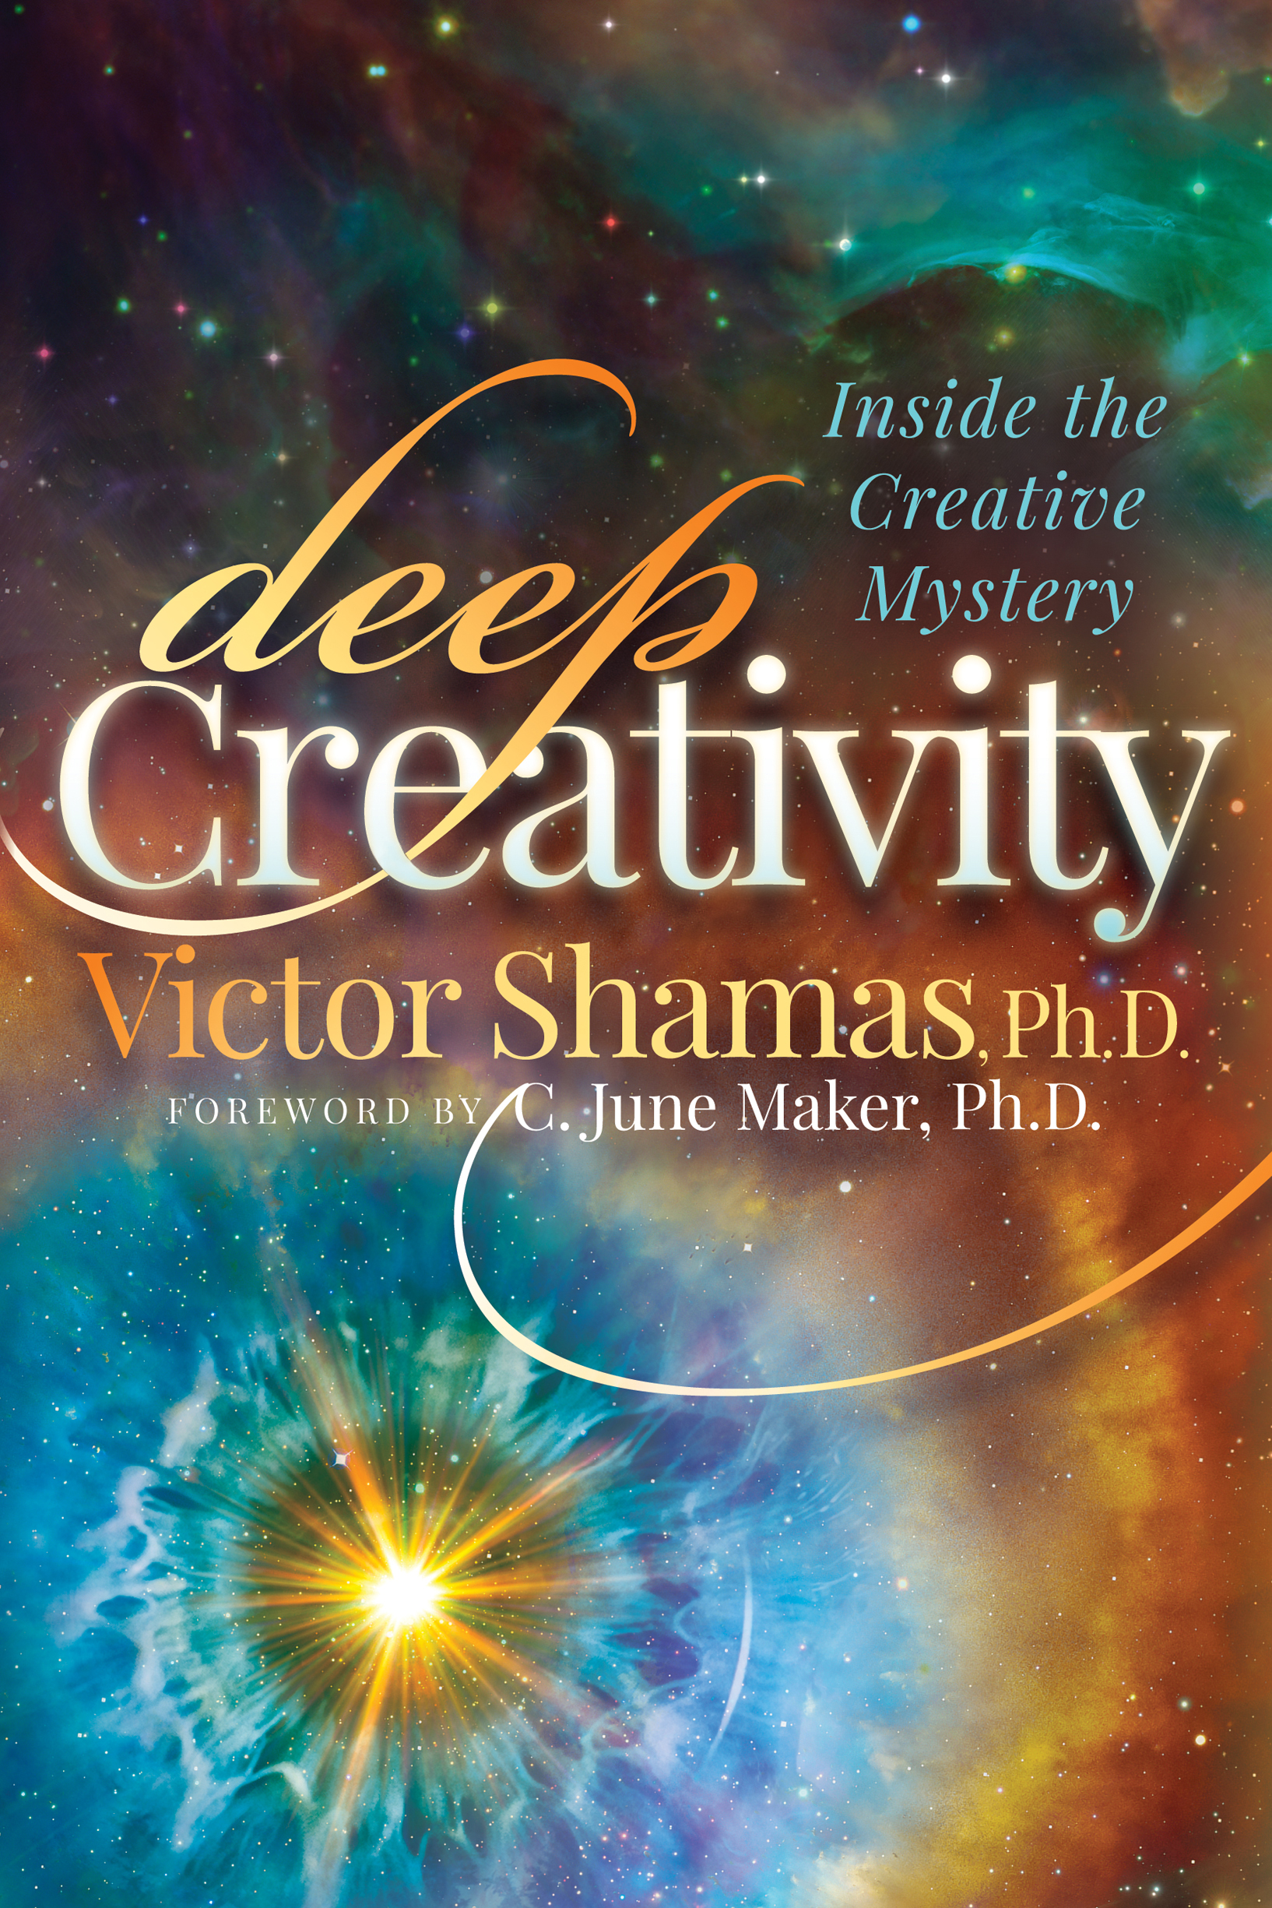

Paperback/E-book
210 pages
6 x 9 inches
Paperback: $17.95
E-book: $9.99
Publisher: Morgan James
Publication Date: March 2018
ISBN-13: 978-1-68350-541-9
Author: Victor Shamas, Ph.D. foreword by C. June Maker, Ph.D.

What is creativity? Where does it come from? How do you fulfill your creative potential? The creative process has remained a mystery to scientific observers reluctant to muddy their results with personal experience. University of Arizona psychologist Dr. Victor Shamas decided to break free of scientific convention, delving into the creative experience directly rather than just observing it in others. His thirty-year exploration of creativity reveals startling answers to basic questions about the nature of creativity.

In Deep Creativity, Shamas turns fundamental assumptions about the creative process on their head. Through a set of Ten Tenets, he re-envisions creativity entirely, linking his own personal experiences with the reflections of eminent artists throughout history while providing groundbreaking insights into the scientific method, fractals, Maslow’s hierarchy of needs, plate tectonics, mind and consciousness, hero myths, the life cycle, sleep and dreams, mothers’ intuition, the nature of wisdom, peak experiences, and even the Gospels.

Deep Creativity integrates art, psychology, philosophy, and mysticism to offer a radical new view of both the creative process and the human condition. The creative experience is portrayed as a bold adventure filled with passion, turmoil, inspiration, sacrifice, sheer joy, self-transcendence, and unconditional love. Deep Creativity shows readers that creativity is not just thinking outside the box but living outside it.
Praise for Books by Dr. Shamas

Deep Creativity

“In the superb and intelligent Deep Creativity, art and mysticism collide. Victor Shamas manages to capture the essence of creativity, reminding us that everyone possesses within themselves a universe of possibilities and that the creative process is a heroic adventure. Deep Creativity touches on the profound mysteries of human existence and offers you the opportunity to move beyond the boundaries and constraints of your own self-identity.” – Dorothy Sisk, Author, Making Great Kids Greater and Spiritual Intelligence

    

“Deep Creativity is an extended meditation on the definitive aspect of what makes us truly human—and what connects us to the divine!” – Lama Marut, Author, A Spiritual Renegade's Guide to the Good Life and Be Nobody

    

“Victor Shamas exuberantly guides the reader to experience the interrelationship between quantum science, philosophy, religion, psychology and individual beliefs, while recognizing the creative expression that each individual already accesses and expresses. His writing style is electric and enjoyable, and his information is transformative!” – Rev. Janis Farmer, Tucson Center for Spiritual Living

    

“This book is like a miracle: rare and of immense benefit. Hats off to Victor Shamas for going into it himself, seeing so clearly, and writing about it so vibrantly. Deep Creativity is the real deal, not a how-to prescription of superficial tips and tricks. These pages offer pure gold for creative, adventurous spirits.”
– Cornelius Boots, woodwind performer-composer and shakuhachi master

The Chanter’s Guide

“This simple yet insightful manual teaches the reader how to tap into the healing power of music. Through sacred music, we can usher in a new era of peace and undersanding on this planet. I believe that the wisdom contained in The Chanter’s Guide can do this.”– Guru Ganesha Singh, Founder of Spirit Voyage Music

    

“A beautiful story of healing and transformation!” – Alice Anderson, Unity Minister and Musician

The Way of Play

“A wonderful and quite fun look at the spirituality of play!” – Linda Kohanov, Author, The Tao of Equus and Riding between the Worlds

    

“Happiness lives in high vibrational emotions such as compassion, forgiveness, and play. This book shows us the way. For all happiness-seeking souls, this is a must read!”– Azim Khamisa, Author, From Forgiveness to Fulfillment

Repose: The Potent Pause

“Repose is a grand gift, a revolutionary technique that at once effectively promotes our physical, psychological and spiritual well-being.” – Rubin Naiman, Ph.D., author of Hush: A Book of Bedtime Contemplations

    

“Want more joy? Read Repose: The Potent Pause. As a healing aid, Repose is better than aspirin. This book should be required reading for every health care provider.” – Amy Weintraub, Author, Yoga for Depression and Yoga Skills for Therapists, Founder of the LifeForce Yoga Healing Institute

    

“The energy of this book feels amazing. Thank you for sharing this gift to humanity.” – Ellie Drew, Author, Way of the Lotus Flower, and Founder of the Institute for Conscious Change

    
About the Author

Victor Shamas, Ph.D.

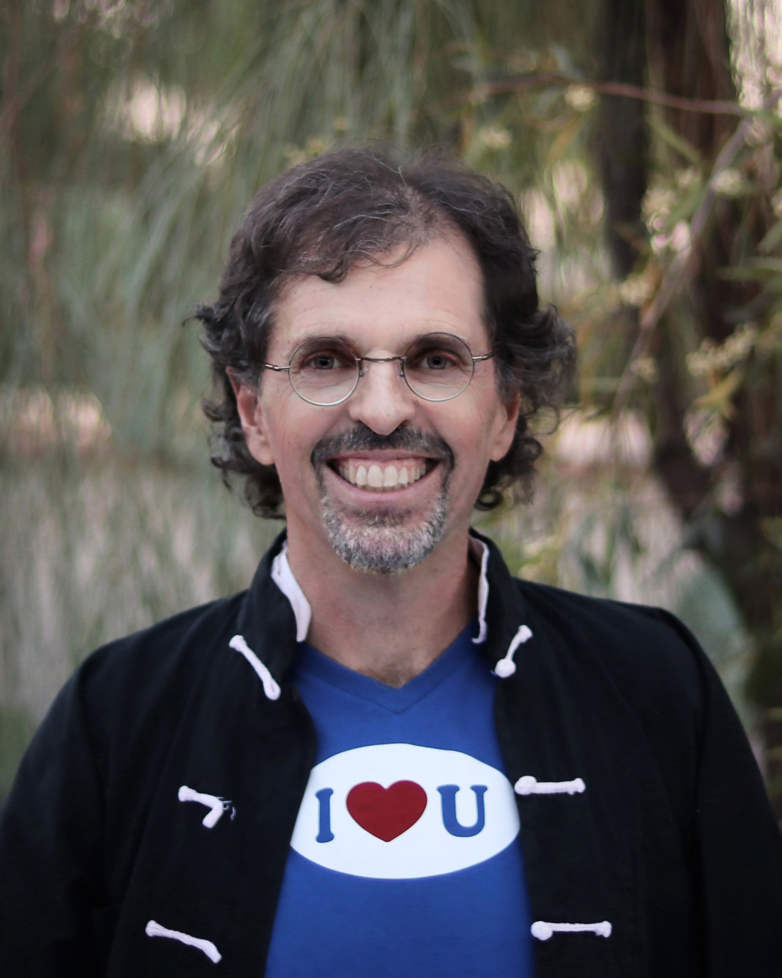
Dr. Victor Shamas has dedicated his life to understanding and exploring the experience of inspiration, as well as the sensations that give rise to it, including: passion, intuition, receptivity, playfulness, and self-transcendence. As a University of Arizona psychologist, he has studied the relationship of inspiration to creativity, health, and wellness. For more than two decades, he has brought together and mentored individuals who, like him, recognize the importance of inspiration as both a source of motivation and a guiding force in their lives.

The experience of inspiration is a central theme in everything Dr. Shamas has written. The Chanter’s Guide details the healing properties of inspiration and explains how the practice of chanting can facilitate this kind of transformative experience. In The Way of Play, he explores the inspiring qualities of play. Repose: The Potent Pause, co-authored with health psychologist Jhan Kold, introduces an inspirational tool that can improve health and productivity at no cost and with minimal effort or time commitment. In Deep Creativity, Dr. Shamas examines the creative power of inspiration and offers specific strategies for getting and staying inspired.

Dr. Shamas heads two groups that promote the experience of inspiration: PlayHaven, which offers creative play for people of all ages, and Global Chant, a network of chanting circles that embraces wisdom and sacred music from all traditions. He has spoken to groups on four continents about inspiration, creativity, play, Repose, chanting, self-transcendence and the future of spirituality. His Intuition in Pregnancy study has been featured in USA Today, Pregnancy magazine, and NBC’s Today show.


To learn more about Victor Shamas and his book, visit www.victorshamas.com.
Facebook Page

@VictorShamas
 Victor Shamas

Media Coverage

Publication of "Mindfulness, Learning, and the Creative Process" by Dr. Shamas and June Maker (March 15, 2018)
Feature on Deep Creativity reaches front page of Google search for "new creativity book" (March 13, 2018)
Dr. Shamas discusses Deep Creativity on "Arizona Spotlight" (March 10-11, 2018)
The entire "Arizona Spotlight" program, including Deep Creativity interview (which starts at -8:05 minute mark)
Dr. Shamas featured in "La Bloga" (March 10, 2018)
Deep Creativity reviewed in Psychology Today (March 10, 2018)
Morgan James Publishing announces the launch of Deep Creativity (March 6, 2018)

"Power Pauses: The Best Way to Break Through Creative Blocks" (Feb 21, 2018)

Audio recording of Dr. Shamas' "Coffee with the Author" presentation at Unity of Tucson (Feb 11, 2018)
Interview on Bringing Inspiration to Earth radio program (Feb 9, 2018)
YouTube video of Dr. Shamas' lecture at the Santa Fe Center for Spiritual Living (Jan 20, 2018)
Part 2 of interview with Dr. Shamas on Freedom Talk Radio UK (Jan 17, 2018)
Article about Deep Creativity in the Las Cruces Bulletin (Dec 15, 2017)

Part 1 of interview with Dr. Shamas on Freedom Talk Radio UK (Dec 5, 2017)
Dr. Shamas' work mentioned in Talkspace article, "The Psychology of Greed" (Nov 24, 2017)
Interview with Dr. Shamas featured in KGUN-9 report about "gut instinct" (Oct 30, 2017)
Dr. Shamas interviewed for intuition article in Bustle (Oct 17, 2017)

Deep Creativity featured in Skyword article about the origins of creativity (Sept 11, 2017)
Intuition in Pregnancy study cited in Witchy Mama by Melanie Marquis & Emily Francis (2016)
Intuition article in Pregnancy magazine (2015)
Intuition study cited in The Whole Health Diet by Mark Mincolla, Ph.D. (2015)
Article about mothers' intuition in Mother Nature Network (2015)
Intuition study critiqued on Statisticsblog.com (2014)
Yahoo Parenting article on Mothers' Intuition (November 11, 2014)
Intuition study cited in Bumpology by Linda Geddes (2014)
Intuition study featured on NBC Today website (April 18, 2013)
Global Chant, PlayHaven and The Way of Play on Arizona Illustrated (January 6, 2011)
Connecticut Post article about mothers' intuition (June 27, 2011)
The Way of Play featured in the Tucson Weekly (December 30, 2010)
The Way of Play featured in the August 2010 issue of Natural Awakenings
Pregnancy Magazine interview (November 13, 2009)
Arizona Daily Star article about the Heart Shrine Relics exhibit
Arizona Spotlight interview with Dr. Shamas (KUAZ-FM, 9-14-07)
Arizona Choices cover story on "The Healing Power of Chant"
Energy Times feature
Arizona Daily Star interview with Dr. Shamas
Tucson Citizen article about mothers' intuition (Sept 26, 1998)

Deep Creativity Tour Dates

March 7, 2017: Institute of Psychology of Paris Descartes, Paris, France
March 14, 2017: “Creative Society” Conference, Florence, Italy
March 21, 2017: Ministry of Education, Orvieto, Italy
September 20, 2017: Unity of Vancouver, Vancouver, WA
October 15, 2017: Green Valley Meditation Group, Green Valley, AZ
November 26 & 29, 2017: Center for Spiritual Living, Tucson, AZ
December 17: Center for Spiritual Living, Las Cruces, NM
December 18, 2017: International Association for Near Death Studies (IANDS) Community Group, Las Cruces, NM
December 18, 2017: Branigan Library, Las Cruces, NM
January 10, 2018: Institute of Noetic Sciences (IONS) Community Group, Taos, NM
January 14, 2018: Santa Fe Center for Spiritual Living, Santa Fe, NM
January 20, 2018: IONS Community Group, Prescott, AZ
February 11, 2018: Unity of Tucson, Tucson, AZ
March 4, 2018: St. Francis in the Foothills, Tucson, AZ
March 10-11: Tucson Festival of Books, Tucson, AZ
March 17, 2018: Barnes & Noble Eastside, Tucson, AZ
March 24, 2018: Barnes & Noble Northwest, Tucson, AZ
April 3, 2018: IONS Community Group, Austin, TX
April 28, 2018: IONS Community Group, Los Angeles, CA
May 13, 2018: IONS Community Group, Colorado Springs, CO
May 16, 2018: IONS Community Group, Denver, CO
May 20, 2018: IONS Community Group, Boulder, CO
June 9, 2018: IANDS Community Group, Seattle, WA
June 10, 2018: Unity of Port Townsend, Port Townsend, WA
June 13, 2018: Third Place Books, Seattle, WA
June 14, 2018: IONS Community Group, Parksville, British Columbia
June 24, 2018: IONS Community Group, Boise, ID

Sample Interview Questions

- What is Deep Creativity?
- How does it differ from other approaches to the study of creativity?
- What are the significant ideas in this book?
- What has been the response to Deep Creativity so far?
- Which of your ideas might be considered most controversial?
- Can you explain the distinction you make between “thinking outside the box” and “living out it”?
- You talk about creative inspiration. What is it and why does it matter?
- What are some of the potential applications of Deep Creativity?
- To whom do you think these ideas will most appeal?
- Some of your critics might dismiss Deep Creativity as being “New Age.” How would you respond to such criticism?
- How do you know that your ideas are right?
- What advice would you give to young artists?
- How will Deep Creativity appeal to individuals who are not engaged in creative pursuits?
- Your book ends with a discussion of unconditional love. How is that relevant to creativity?
- What impact do you see Deep Creativity having on people’s lives?
- One of the central themes of your work is this idea of staying inspired. How does one do that?
- Your previous books have dealt with a wide range of topics, including play, sacred chanting, shamanic healing, and a relaxation technique called Repose. Are there underlying themes in this work? If so, what are they?
- What do you see as your legacy? How do you see your life’s work making a difference in the world?

