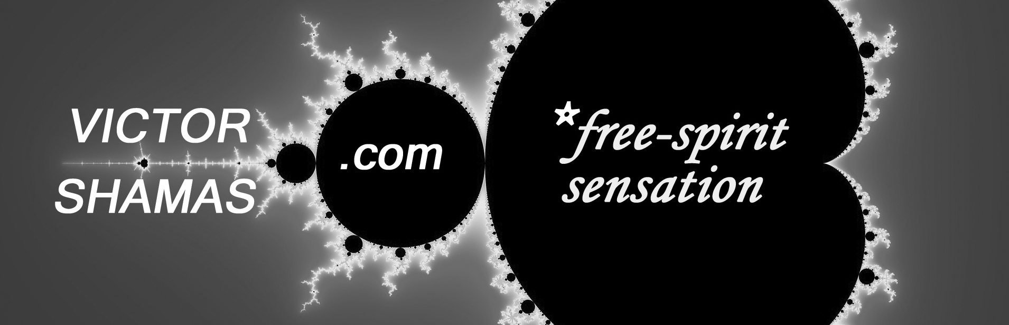
INTRODUCTION OF VICTOR SHAMAS, PH.D.
Dr. Victor Shamas has devoted his life to exploring and understanding the experience of being fully alive. As a psychologist, author, lecturer, and spiritual adventurer, he offers a unique perspective on the role this type of experience plays in creativity and well-being.
1. For more than two decades, he has mentored and brought together free spirits from every part of the world, through:
- The two non-profit groups he co-founded: Global Chant and PlayHaven;
- His four books, which include Deep Creativity: Inside the Creative Mystery and the Amazon best-seller, Repose: The Potent Pause;
- The global events he has organized, which have attracted more than one million participants in 40 countries;
- His speaking engagements, through which he has connected with audiences on four continents.
2. He has put his ideas about Deep Creativity into practice and demonstrated their effectiveness by:
- Producing over 200 videos that have been viewed by more than 185,000 people;
- Writing several hundred musical compositions, many of which can be found on his two music CDs and his YouTube videos;
- Developing and teaching 25 undergraduate courses in psychology for the University of Arizona;
- Creating an anti-inflammatory health program, called Victor’s Inflammation Mend (VIM), to lower the risk of chronic illness;
- Directing the Intuition in Pregnancy study, which has been featured in USA Today, Pregnancy magazine, and NBC’s Today show.
3. He is a free thinker who has promoted:
- Alternative higher education free of grades and majors;
- New models of spiritual community for those who do not identify with traditional religions;
- A radical new vision of human creativity
He is here today to speak to us on the topic of Deep Creativity. Please join me in welcoming Dr. Victor Shamas.

